**User Guidelines**

**Application Requirement:**

* Android Version: 2.5 or later
* Processor: no less than 500 MHz
* RAM: at least 200 MB
* Storage: at least 516 MB
* Internet require: Yes
* Microphone require: Yes

**Guidelines for using an application**

Firstly an application “***Improve Speech***” must be installed on the user’s android device.

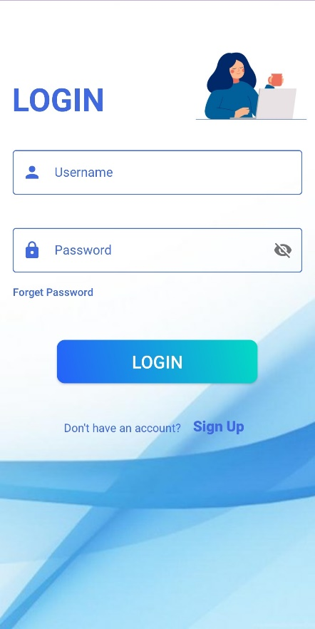

*Fig 1: Login UI*

After opening an application the Login User-Interface (UI) is displayed as shown in Fig 1. If the user has already the login credentials they can directly Login to application by entering their login details. If the user doesn’t have their login details they can click on the Sign Up button for registration.

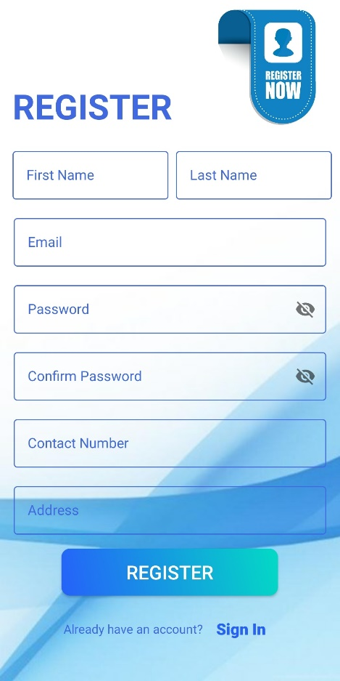

*Fig 2: Register UI*

After clicking on Sign Up button it redirects the user to register page. There it includes all the necessaries field require for registration. It includes (i.e. Full Name, Last Name, Email, Password, Confirm Password, Contact Number and the Address). The user must fill their information according to field. After filling up all the details the user must click register button for registration. The message pop up showing that either the registration is successful or failed.

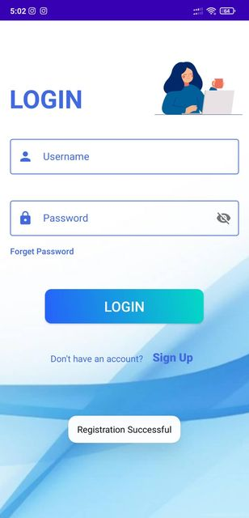

*Fig 3: Message showing Registration Successful*

After successfully registering into the application the message pops up showing Registration Successful and redirects the user to Login page.

In case the user forget their password they can click on the Forget Password button as shown in Fig 4.

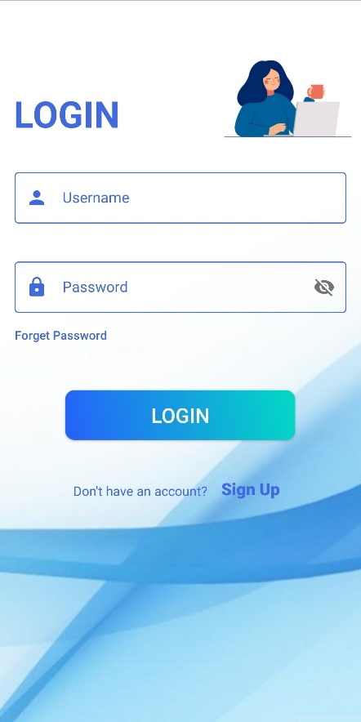

*Fig 4: Showing Forget Password Button*

It then redirects the user to Reset Password Page as shown in Fig 5. There they have to fill the email that they previously used for registration.

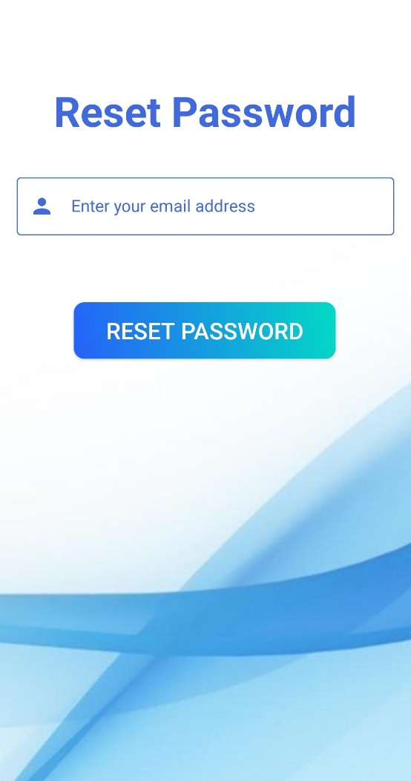

*Fig 5: Reset Password UI*

After filling up the correct email user must click on reset password button.

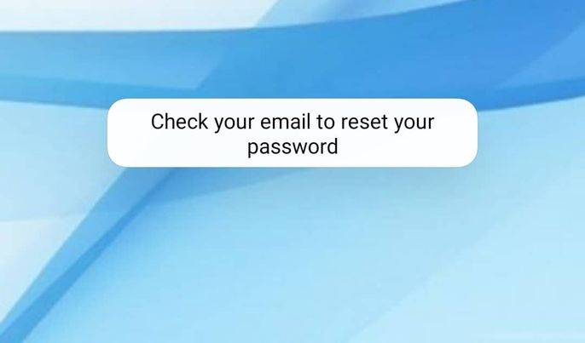

*Fig 6: Message showing to reset the password*

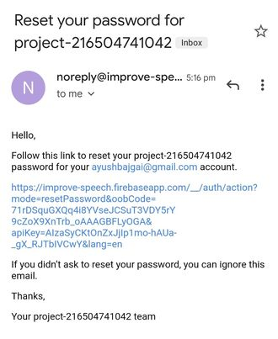

*Fig 7: Reset password sent via E-mail*

The message shows up stating the user to check their corresponding email to reset their password as shown in Fig 6. The reset link is sent to the user’s email. By clicking on the link the user can reset their password.

Now the user can login to application by using their login details as shown in Fig 1.

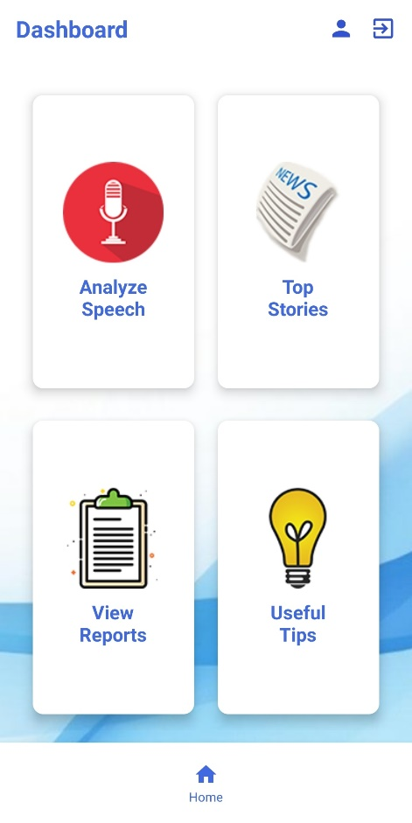

*Fig 7: Dashboard UI*

After successfully login into system user is then redirect to their dashboard page respectively. The dashboard page includes:

Analyze Speech for checking user’s grammar via speech, Top Stories for getting the latest news globally, View reports for viewing their reports, Useful tips for providing user with beneficial tips.

Also there is the profile icon on top which redirects the user to view their profile and exit icon for logging the user out from the system.

Below there is home icon which directs the user to dashboard page.

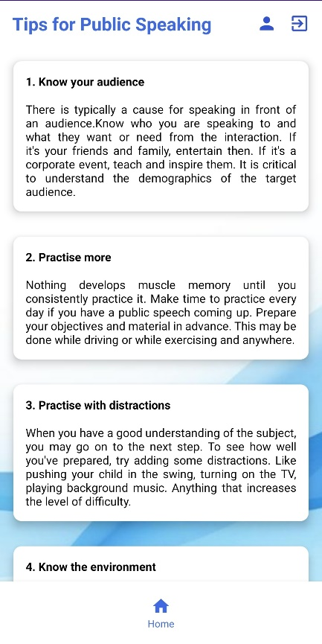

*Fig 8: Tips for Public Speaking UI*

Clicking on the Useful tips redirects the user to Tips for Public Speaking UI as shown in Fig 8. There they get useful tips regarding how to improve public speaking skills and presentation skills.

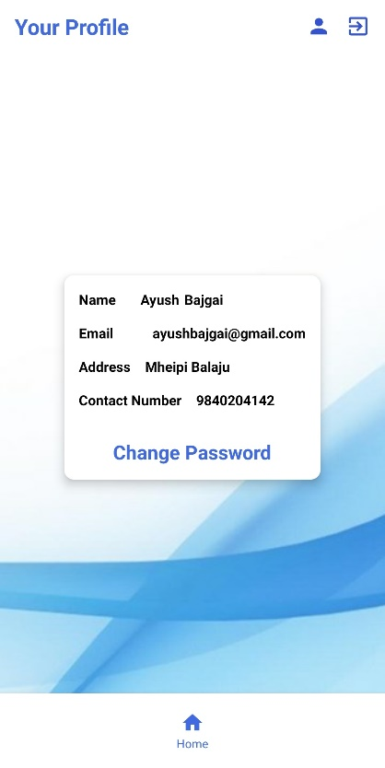

*Fig 9: View Profile UI*

Clicking on the Profile icon redirects the user to Profile UI as shown in Fig 9. They can view their profiles as set by them during registration. They can also change the password by clicking on Change Password button. It then redirects the user to Change Password page as shown in Fig 10.

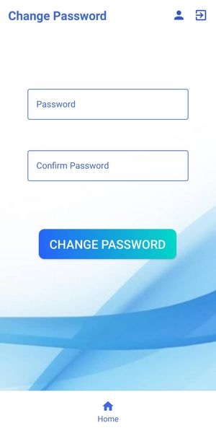

*Fig 10: Change Password UI*

User can change their password according to their need. The two text field includes password and confirm password allows the user to change their password. After successfully writing the password user should click on Change Password button in order to update their password.

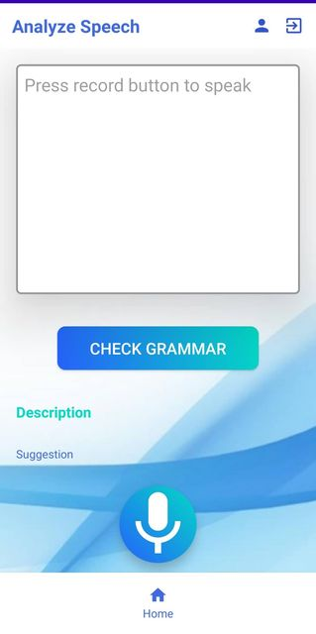

*Fig 11: Analyze Speech UI*

Clicking on the Analyze Speech redirects the user to Analyze Speech UI as shown in Fig 11. There it includes text field for transcribing user voice to text. Also user can write the text and check whether the provided sentence is correct or not. The record button is for getting the users voice. The user can click on record button and start saying a word as shown in Fig 12. Then the system transcribes the user voice into text as shown in Fig 13.

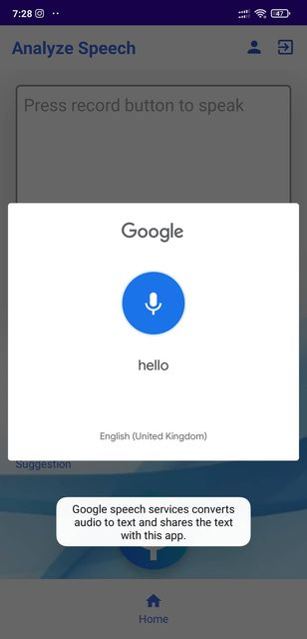

*Fig 12: Getting user voice*

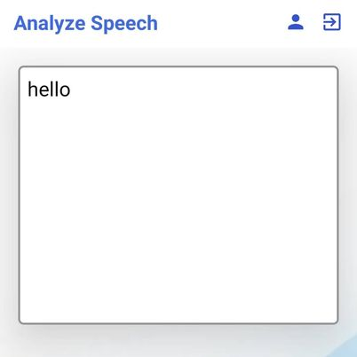

*Fig 13: Transcribing user voice to speech*

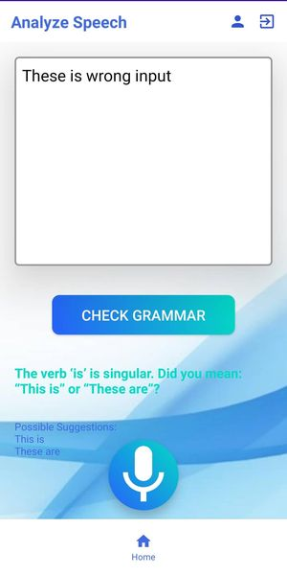

*Fig 14: Description and Suggestion*

After clicking check grammar button the system checks the inputted grammar and provides Description and Suggestion to the user as shown in Fig 14. Then the report is auto generated in View Report page as shown in Fig 14.

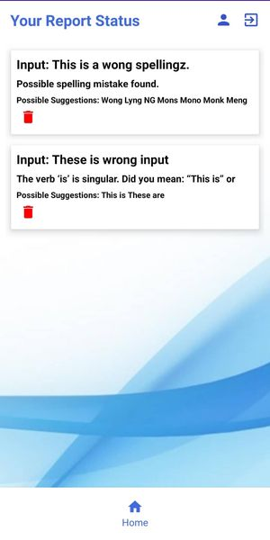

*Fig 14: View Report UI*

The details of the users grammar is checked analyzed and suggested as shown in Fig 14. The user can view their grammar status accordingly.

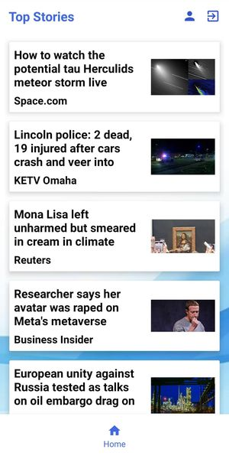

*Fig 15: View Report UI*

Clicking on (Fig 7) the Top Stories redirects the user to Top Stories UI as shown in Fig 15. They can view the latest news and stories globally. The top stories is placed so that user gets entertain and also while clicking on the news they can read the news article which also helps them to improve reading and skimming skills.

Clicking on (Fig 7) the Logout icon pops the message confirming the user to logout of the system. The user can click No on continuing with the application or click Yes for terminating out of the system.

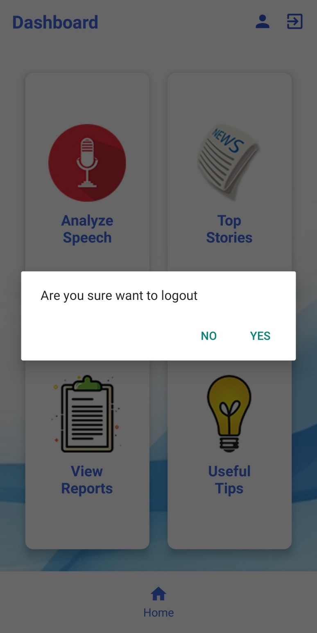

*Fig 16: Logout Pop up*